

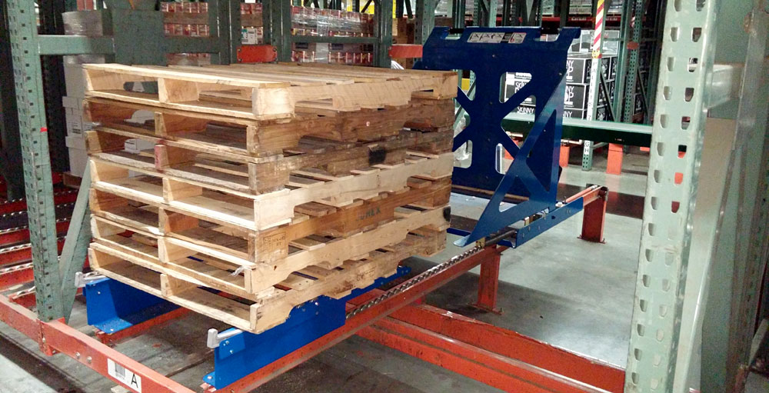

A Perfect Stack, Everytime…

Conventional Pallet Collection Methods

Despite the general industry shift toward e-Commerce fulfillment and more piece picking operations, many distribution centers rely on full case order selection as the engine that drives product through the supply chain. The very nature of the business means two things: first, employees are required to manually handle thousands of cases every year which undeniably put a lot of wear and tear on the human body, secondly, employees must deal with the pallet on which the cases arrived and were stored. These pallets weigh anywhere from 40 to 80 pounds, are awkward to handle, contain slivers, nails, dirt, dust and residues. Today’s distribution centers are faced with the challenge to lower costs. The problem lies in the fact that rising productivity means handling more cases and more pallets, which significantly increases the risk of a potential injury, thus wiping out savings from productivity gains and more.

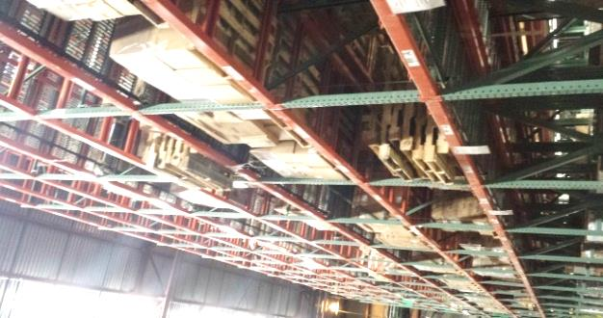
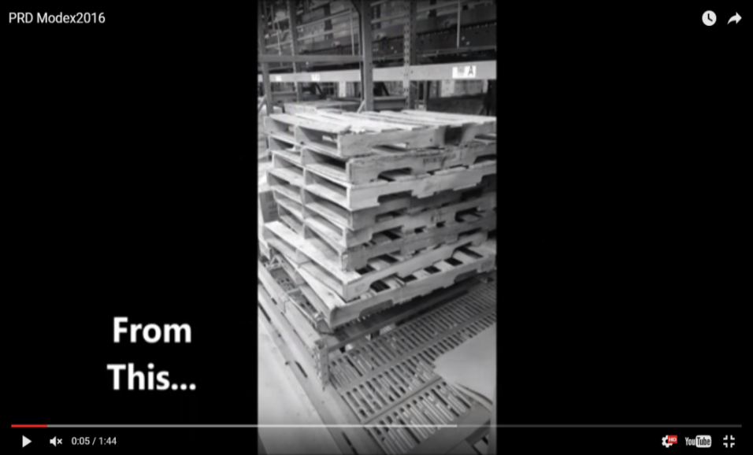
The conventional method of collecting empty pallets from a case pick module, pick tunnel, or even a floor picking operation involves the manual stacking of pallets. Typical in-rack configurations would have the stack sitting on a set of pallet flow rails pitched away from the order selector with a single hook or lever that retains the stack from flowing down the rails. It may include a board or plate on one side that assists the selector by allowing them to slam the pallet against it as it falls to the stack (aka Bang Board). In practice, this bang board does not actually increase the quality of the stack, is rarely used and the motion it requires creates a twisting of the torso.

The process of stacking a pallet can be completed by the average selector in 11.15 seconds. However, it is marred with health and safety risks as the pallet must be manually lifted onto the stack, putting undue stress on the shoulders, back and wrists. The single point of retention allows for the stack to shift when pallets are added. The order selector may try to align the pallet once on the stack which exposes hands to slivers, nails and whatever residual substances may be on the pallet. As the stack grows taller it becomes more difficult for the order selector to safely lift the pallet to the top of the stack and align or adjust once there. Often there are rate standards to be met and the stack is left as is or “good enough” in the mind of the selector.

In this arrangement the release of a stack takes the average selector 7.55 seconds to pull a lever and give a slight push to assist the flow. Due to pallets’ weight and awkward size, the stack is often less than perfect; at least 50% of the time it will require rework later in the process. In a deep flow pick module it often shifts causing a dangerous situation with pallets hanging outside of the rack structure, getting stuck or otherwise being unsafe to be picked up by a forklift. This requires additional time and care for the forklift operator to remove the stack. At some point this will require manual intervention with a man-up lift or the specialized fall protection needed equipment to climb into the racking system and free a stack that became stuck, or to retrieve and restack the pallets so that a forklift can safely handle the load. At worst, an employee tries to do that without the proper equipment creating a possible catastrophic injury.

Using MaxiMOST, the standard time to retrieve a load from pallet rack is 35.97 seconds. The time required to safely retrieve a poor stack of pallets from a multi-level pick module via forklift is highly variable; however, it would not be uncommon to find that it doubles. The waste is not complete yet as the forklift operator will need to straighten the stack. This can be accomplished manually through a series of pushing and pulling steps totaling 33.45 seconds. Furthermore, this activity presents a high injury risk for the forklift operator who is unlikely to warm up or stretch and is trying to slide the pallets to align them from an awkward position typically using a jerking type motion.

The Safest, Most Efficient Way to Handle Pallets
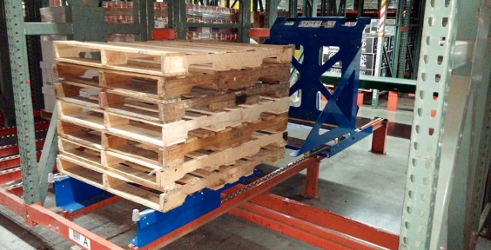
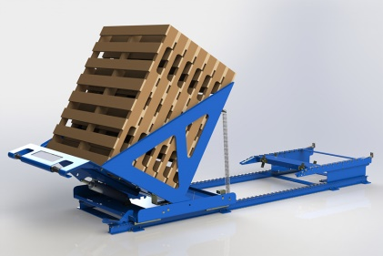
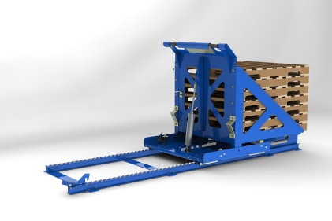
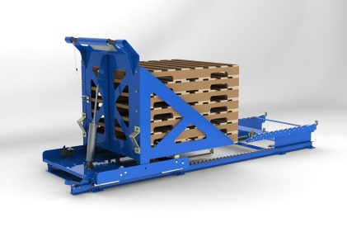
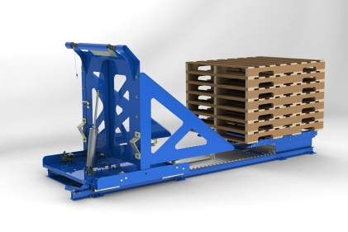
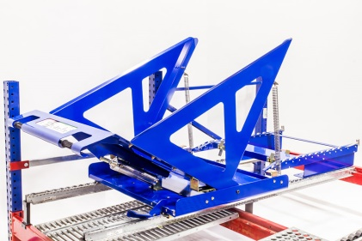
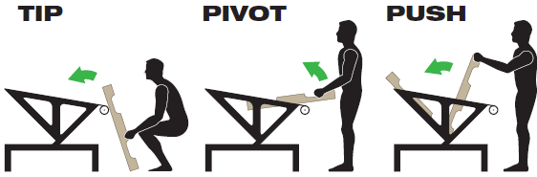
To reduce the risk of injuries and accidents, employ the use of the Pallet Return Device (PRD). The PRD is a simple to use device that gives the order selector a mechanical advantage over the pallet. Following the simple instructions that are embedded on the device the order selector loosely aligns the pallet to the carriage and tips the pallet against it. This serves two purposes, the first is that it effectively reduces the force required to lift the pallet and second allows the use of proper lifting techniques to keep the load in the power zone. The order selector lifts the other end of the pallet, pivoting it on the handle and lightly pushes the pallet as it rotates into the carriage. The device ensures that the pallet stack is perfectly even front to back. There is no need for adjustments so the time to complete is 10.07 seconds.

Once the seventh pallet is loaded, the operator grasps the handle, gives a slight twist to release a latch and gently pulls to begin the rotation of the carriage. The PRD’s springs assist the load until the center of gravity reaches the pivot point at which point the cylinder controls the rotation. The operator presses the foot release and pushes the stack to the receiver located at the pickup position. The stack is automatically transferred to the receiver and the empty carriage is returned to the picking aisle and rotated to the load position. This operation is completed in 15.47 seconds.

The motion and process is identical from the first to the seventh pallet.
When the pallet is removed from the picking slot, it is tipped away from the operator preventing any debris or residue flying at the face and eyes of the order selector. There is no need to rotate the pallet for the stacking as this presents the pallet in the correct orientation to leverage the mechanical advantage at the PRD. The forklift operator is always presented with a stack that is easily retrieved from the racking structure and does not require any manual intervention.

The PRD can be outfitted with an optional sensor and flashing light to alert the forklift operator that a stack is available to be removed. This provides for additional efficiencies of the forklift operator by batching tasks in an area and the order selector who does not need to wait for a return lane to be emptied. This also provides a visual management tool to ensure that forklift operators are not trying to cherry pick only replenishment tasks for rate purposes.

Return On Investment

The process comparison starts from the point where the order selector has taken the pallet to the return location. Using conventional methods the total standard time per pallet is calculated at 26.8 seconds after applying event frequencies. This includes the time for the order selector to put the pallet on the stack, occasionally aligning the pallet on the stack, releasing the stack, retrieving the stack with a forklift and manually restacking when necessary. Using the Pallet Return Device, the total standard time per pallet is calculated at 17.2 seconds. This includes time to put the pallet into the carriage, release and push to the pickup location, return to the picking aisle and retrieval of the stack with a forklift. That is a 35% reduction in an activity that does not add any value to the product being picked and shipped.

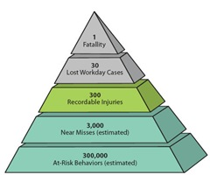
The larger opportunity for savings comes from the reduction in potential for injuries and accidents. Many risk management and safety experts have applied the concept of the safety triangle when assessing the risk of an injury. One version of the Safety Triangle developed by Conoco Phillips established a ratio of 10,000 : 1 for at-risk behaviors to a lost time injury.
Figure 1: Safety Triangle - http://crsp-safety101.blogspot.com/2012/07/the-safety-triangle-explained.html

The work of full case order selection is a physically demanding job task, but the lifting and stacking of pallets creates an unneccessary at-risk behavior for an order selector due to the size, weight and the height of the stack. For the majority of the population, this could easily mean up to 40% of pallets stacked present a higher risk of injury to the selector. If a typical order selector picks 250 cases per hour and the average pallet contains 50 cases, over the course of a year the order selector will handle 10,000 pallets. The potential for injury becomes a mathematical inevitability.

The likely injuries would be those to the back, shoulders, arms, wrists or fingers. Based on figures from a recent National Safety Council report, the average cost of an injury including indemnity and medical care is $33,214 (weighted by relative frequency of applicable body parts). In addition, the facility is faced with training a replacement for the injured worker or working additional costly overtime to ensure the production objectives are completed.
Applying the Heirarchy of Control, the most effective measure would be to eliminate or substitute the risk, however automating an existing distribution center is extremely expensive, and pallets are a necessary utility for the transportaion of the majority of goods. The next best method and most practical solution to reduce the exposure to at-risk behaviors and ultimately lower costs is to utilize an engineering control such as the Pallet Return Device. Contact your factory representative or material handling integrator today - you can’t afford to wait.

Appendix A – Industrial Engineering Commentary

Detailed MOST analysis - Conventional Stacking Method

The conventional arrangement is that of pallet flow rails pitched away from the picking aisle. The typical configuration would have a lever/handle connected to a bar or retainer to keep the pallets from rolling down the rails until the stack is full. For this analysis the Distribution Center allows a full stack to be five (5) high. Events that don’t happen every cycle are calculated by mapping a “volume driver” based on the relative number of times it happens per pallet. The MOST analysis of the operation begins when the order selector has already taken the pallet to the return location and it is assumed to be resting on the walking surface of the pick aisle under the control of the order selector while on its side.

The first action is a BEND AND ARISE to pick up the pallet. Due to the awkward size and weight, the selector will have a slight pause signifying a GET. During the put phase of this general move, the selector will typically take 3–4 small steps as they walk the pallet to the final stack location. The put phase would be characterized as a PLACE because the selector has to apply light pressure in an upward direction to keep from losing complete control of the pallet as they guide it down to the stack. The resulting sequence model is: A₁B₆G₃A₆B₀P₃A₀ = 190 TMU. Applying volume driver mapping (1), this contributes 6.83 seconds to the standard time.

Again, due to the size and weight of the pallet, the order selector typically can only guide the pallet to somewhat of an approximate position on the stack. Based on field observations, the pallet needs alignment approximately 60% of the time. This requires the operator to grab the pallet which is characterized by a GET that is within reach. The order selector must PUSH or PULL the pallet while taking 1–2 small steps in an attempt to align the stack making this a controlled move. There is no true alignment activity as it is really an approximate shifting. This typically requires more than one action. The resulting sequence model is: A₁B₀G₃M₆X₀I₀A₀ 2 = 200 TMU. Applying volume driver mapping (0.6), this contributes 4.32 seconds to the standard time.

These operations are repeated until the stack is full. Once the stack is full the retaining the lever is released. The order selector GRASPS the release bar with a BEND AND ARISE. The activity is a controlled move as they turn the handle to release and then return the handle to the original position. This qualifies as a 2-stage move (< 24”) of total motion. It is important to note that while the 2–stage motion is accounted for here, the next two sequence models are part of this overall activity as well and happen during this sequence. The resulting sequence model is: A₁B₀G₁M₃X₀I₀A₀ = 110 TMU. Applying volume driver mapping (0.2), this contributes 0.79 seconds to the standard time.

The order selector reaches out to contact the stack and give a slight PUSH (> 12”) to get it moving. The operator then must wait for the stack to clear the retaining mechanism, approximately 1 second. The resulting sequence model is: A₁B₀G₁M₃X₃I₀A₀ = 80 TMU. Applying volume driver mapping (0.2), this contributes 0.58 seconds to the standard time.

The order selector still has control of the handle and must PUT it aside. The resulting sequence model is recorded as: A₀B₀G₀A₁B₀P₁ A_{0.} = 20 TMU. Applying volume driver mapping (0.2), this contributes 0.14 seconds to the standard time.

At this point the process work transfers from the order selector to the lift truck operator. To estimate the next step, MaxiMost is utilized. The lift truck operator is assumed to already be on a powered truck and in the area replenishing pallets to the pick module, so the activities being modeled are the raising of the forks, retrieval of the stack onto the forks and the lowering of the stack from the return lane to the ground. This results in a MaxiMOST sequence model: A₀S₀T₀L₁₀T₀L₀A₀ = 1,000 TMU or 35.97 seconds. To translate that into Basic MOST, we utilize the extended process time estimate table and write the model as A₀B₀G₀M₀X₉₆I₀A₀ = 960 TMU. Applying volume driver mapping (0.2), this contributes 6.90 seconds to the standard time.

The previous step accounts for the time when the stack is properly stacked. However, more often than not (53%) the stack has either shifted or was not stacked well by the selector (despite the attempted adjustments in earlier steps). The analysis does not attempt to model the activity when a stack becomes stuck part way down the pallet flow rail in the rack module. This would require intervention with fall protection equipment or the use of poles and hooks and will vary depending on the organization's safety requirements. The risk in this step is that an order selector may attempt to free the stack without following proper safety procedures and the result could be catastrophic. For the purpose of this analysis, the alternative is to allow additional time for the lift truck operator to safely maneuver the stack out of the rack. This will vary but field observations suggest a conservative estimate is that it doubles the overall retrieval time noted in the previous step (960 TMU). Applying volume driver mapping (0.106), this contributes 3.66 seconds to the standard time.

At this point, the lift truck operator must properly straighten the stack of pallets. Those familiar with distribution centers often notice racks and columns are slightly damaged or missing paint. It is typical that lift truck operators will push a poorly aligned stack against a structure with the lift truck. The operator would set the stack down, pick it up from the side and repeat the process of pushing against the structure. Since this is not considered proper operation for a lift truck, the analysis models the activities required to manually align the stack. This requires a dismount of the lift truck and walking to the stack, a total of 5–7 steps. The operator must GET control of a pallet with a BEND AND ARISE and PUSH or PULL the pallet (≤ 12”) until it is actually aligned (1-point) along one side. The resulting sequence model is: A₁₀B₆G₃M₃X₀I₁A₀ = 230 TMU. Applying volume driver mapping (0.106), this contributes 0.88 seconds to the standard time.

The activity is then repeated for the subsequent pallets (without the bend and arise body action) in two directions until the stack is aligned and the lift truck operator returns to the equipment 5–7 steps. The resulting sequence model is: (A₃B₀G₃M₃X₀I₁)A₁₀ (6) = 700 TMU. Applying volume driver mapping (0.106), this contributes 2.77 seconds to the standard time.

The total standard time is calculated to be 26.77 seconds per pallet. The chart below breaks the process down to show which steps account for the largest percentage of the standard time. To understand the waste hidden in this process, a Value Added versus Non-Value Added analysis of the process steps is employed. While technically everything in this process is Non-Value Added, the business need is to get the pallets out of the picking area and will be classified as Value Added. In this analysis 43% of the time used in the process is pure Non-Value Added waste.
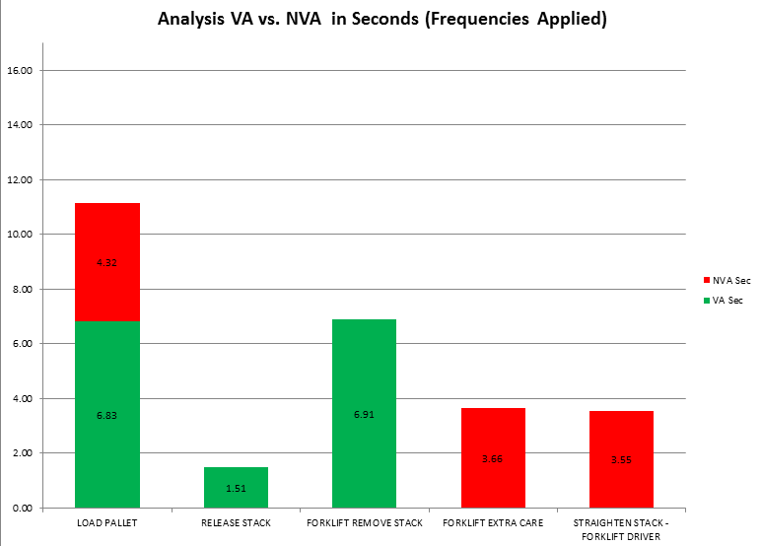
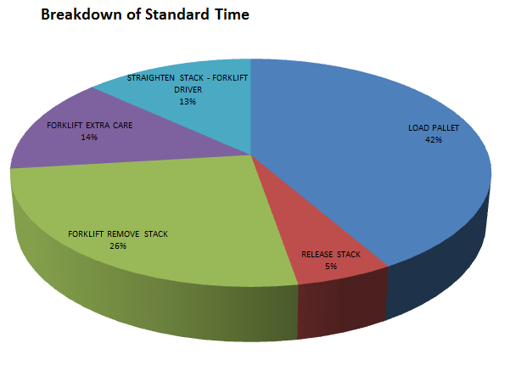

Detailed MOST analysis - Pallet Return Device

The Pallet Return Device can accommodate seven (7) pallets in a stack before they must be deposited to the pickup location. Events that don’t happen every cycle are calculated by mapping a “volume driver” based on the relative number of times it happens per pallet. Just as with the conventional method, the MOST analysis of the operation begins when the order selector has already taken the pallet to the return location and it is assumed to be resting on the walking surface of the pick aisle under the control of the order selector while on its side.

The order selector must first ensure the pallet is aligned to the PRD. This final alignment step requires a controlled move to PUSH (≤ 12”) the pallet and an alignment step (1–point). The pallet is assumed to already be under the control of the order selector. The resulting sequence model is: A₀B₀G₀M₁X₀I₁A₀ = 20 TMU. Applying volume driver mapping (1), this contributes 0.72 seconds to the standard time.

The order selector then leans the pallet against the PRD carriage. This is a PUT within reach; again the selector already had control of the pallet. The resulting sequence model is: A₀B₀G₀A₁B₀P₁A_{0.} = 20 TMU. Applying volume driver mapping (1), this contributes 0.72 seconds to the standard time.

The order selector then must take 1–2 small steps to gain control of the pallet with a BEND AND ARISE. Even though the pallet is leaning against the PRD and the force required to lift is reduced, the action would still be characterized by a GET. The pallet is in contact with the PRD so it is not freely moved making this a controlled move. The motion is characterized as a PULL (> 12”). The resulting sequence model is: A₃B₆G₃M₃X₀I₀A₀ = 150 TMU. Applying volume driver mapping (1), this contributes 5.40 seconds to the standard time.

The selector must re-grasp the pallet as it pivots into the carriage. The majority of the weight is being held for the order selector so this is characterized as a GRASP. The motion is characterized as a PUSH while taking 1-2 steps. The resulting sequence model is: A₁B₀G₁M₆X₀I₀A₀ = 80 TMU. Applying volume driver mapping (1), this contributes 2.88 seconds to the standard time.

The time to relinquish control of the pallet must be accounted for, so the put phase of a general move is applied. Since the pallet is released and gravity takes it into the carriage stack, the action is best described as a TOSS. The resulting sequence model is: A₀B₀G₀A₁B₀P₀A_{0.} = 10 TMU. Applying volume driver mapping (1), this contributes 0.36 seconds to the standard time.

After seven pallets, the carriage is full and must be released. The selector GRASPS the handles of the carriage and TURNS to release. The resulting sequence model is: A₁B₀G₁M₁X₀I₀A₀ = 30 TMU. Applying volume driver mapping (0.143), this contributes 0.15 seconds to the standard time.

The selector maintains control of the handle and PULLS (> 12”) up with the resistance of gravity. This distance takes the stack’s center of gravity beyond the pivot point of the carriage. At this point the rotation of the carriage is controlled by the cylinder on the carriage and it automatically latches in the down position. Control of the handle is maintained. The resulting sequence model is: A₀B₀G₀M₃X₀I₀A₀ = 30 TMU. Applying volume driver mapping (0.143), this contributes 0.15 seconds to the standard time.

The selector takes 1–2 steps to PUSH (≤ 12”) the pedal with a foot. The selector maintains control of the handles through this step. The resulting sequence model is: A₃B₀G₁M₁X₀I₀A₀ = 50 TMU. Applying volume driver mapping (0.143), this contributes 0.26 seconds to the standard time.

The selector PUSHES the carriage 3–4 steps to deposit the stack on the receiver and then PULLS the carriage 3–4 steps to return to the carriage to the loading position. Control of the handle is maintained throughout this activity. The resulting sequence model is: A₀B₀G₀M₁₀X₀I₀A₀ 2 = 200 TMU. Applying volume driver mapping (0.143), this contributes 1.03 seconds to the standard time.

With the handle still in control, the selector TURNS (≤ 12”) to release the latch and maintains control. The resulting sequence model is: A₀B₀G₀M₁X₀I₀A₀ = 10 TMU. Applying volume driver mapping (0.143), this contributes 0.05 seconds to the standard time.

The selector PULLS (> 12”) the handle to rotate the carriage back to the final loading position, control of the handle is maintained. The resulting sequence model is: A₀B₀G₀M₃X₀I₀A₀ = 30 TMU. Applying volume driver mapping (0.143), this contributes 0.15 seconds to the standard time.

The selector must then relinquish control of the handle with a LAY ASIDE WITHIN REACH and return to the picking aisle by taking 3–4 steps. The resulting sequence model is: A₀B₀G₀A₁B₀P₁A₆= 80 TMU. Applying volume driver mapping (0.143), this contributes 0.41 seconds to the standard time.

As with the conventional method, at this point the process work transfers from the order selector to the lift truck operator and MaxiMost is utilized to estimate the time. The lift truck operator is assumed to already be on a powered truck and in the area replenishing pallets to the pick module, so the activities being modeled are the raising of the forks, retrieval of the stack onto the forks and the lowering of the stack from the return lane to the ground. This results in a MaxiMOST sequence model: A₀S₀T₀L₀T₀ L₁₀A₀ = 1,000 TMU or 35.97 seconds. To translate that into Basic MOST, we utilize the extended process time estimate table and write the model as A₀B₀G₀M₀X₉₆I₀A₀ = 960 TMU. Applying volume driver mapping (0.143), this contributes 4.93 seconds to the standard time.

At this point the operation is complete. The Pallet Return Device has successfully eliminated the wasted steps of realigning the pallets and the additional time required to retrieve or free a stack of pallets.

The total standard time is calculated to be 17.2 seconds per pallet. Applying the same Value Added analysis, we see that unnecessary waste has been removed from the process. The total improvement is a 35% reduction in an activity that does not add any value to the product being picked and shipped.

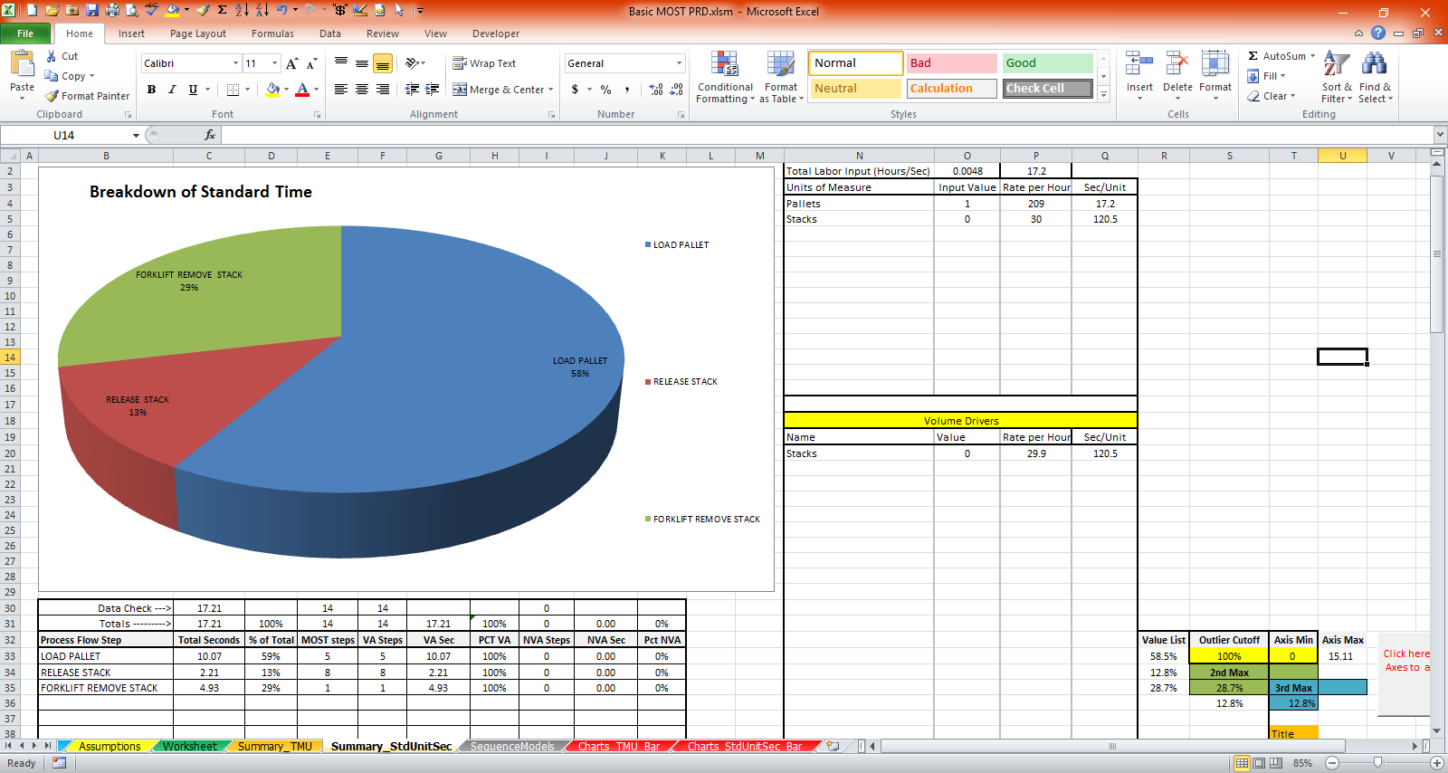
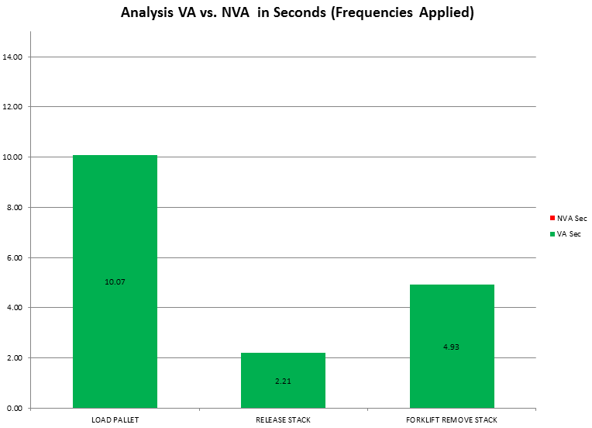

For a detailed engineered time analysis of the processes using MOST, see the Industrial Engineer’s discussion in Appendix A.
National Safety Council. (2013) Injury Facts®. 2013 Edition. Itasca, IL
https://www.cdc.gov/niosh/topics/hierarchy/
EMPHASIS added for keywords and action distances from the MOST data card to denote the index value used
Time is calculated with no rounding, due to rounding in each step, the addition of the stated individual values does equal 26.77.

